THIS ENDORSEMENT CHANGES THE POLICY. PLEASE READ IT CAREFULLY.

THEFT EXCLUSION
This endorsement modifies coverage provided under the following:
AUTO DEALERS COVERAGE FORM
With respect to coverage changes made by this endorsement, the provisions of the Coverage Form apply unless modified by this endorsement.

Named Insured:  Morris Avenue Auto Sales | Policy Number:
Endorsement Effective:  11/4/2025 | Countersigned By:  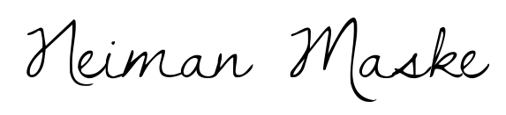  (Authorized Representative  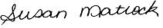
(Authorized Representative)

It is agreed that:

SECTION I – COVERED AUTOS COVERAGES, F. Physical Damage Coverage, 3. Exclusions is amended to add the following exclusion:

Theft

We will not pay for “loss” to a covered “auto” caused by or resulting from theft or attempted theft.

This endorsement shall apply to any continuation, reinstatement, renewal or replacement of the above mentioned policy by the Named Insured.

_____________________________________ _____________________
Signature of Insured Date

